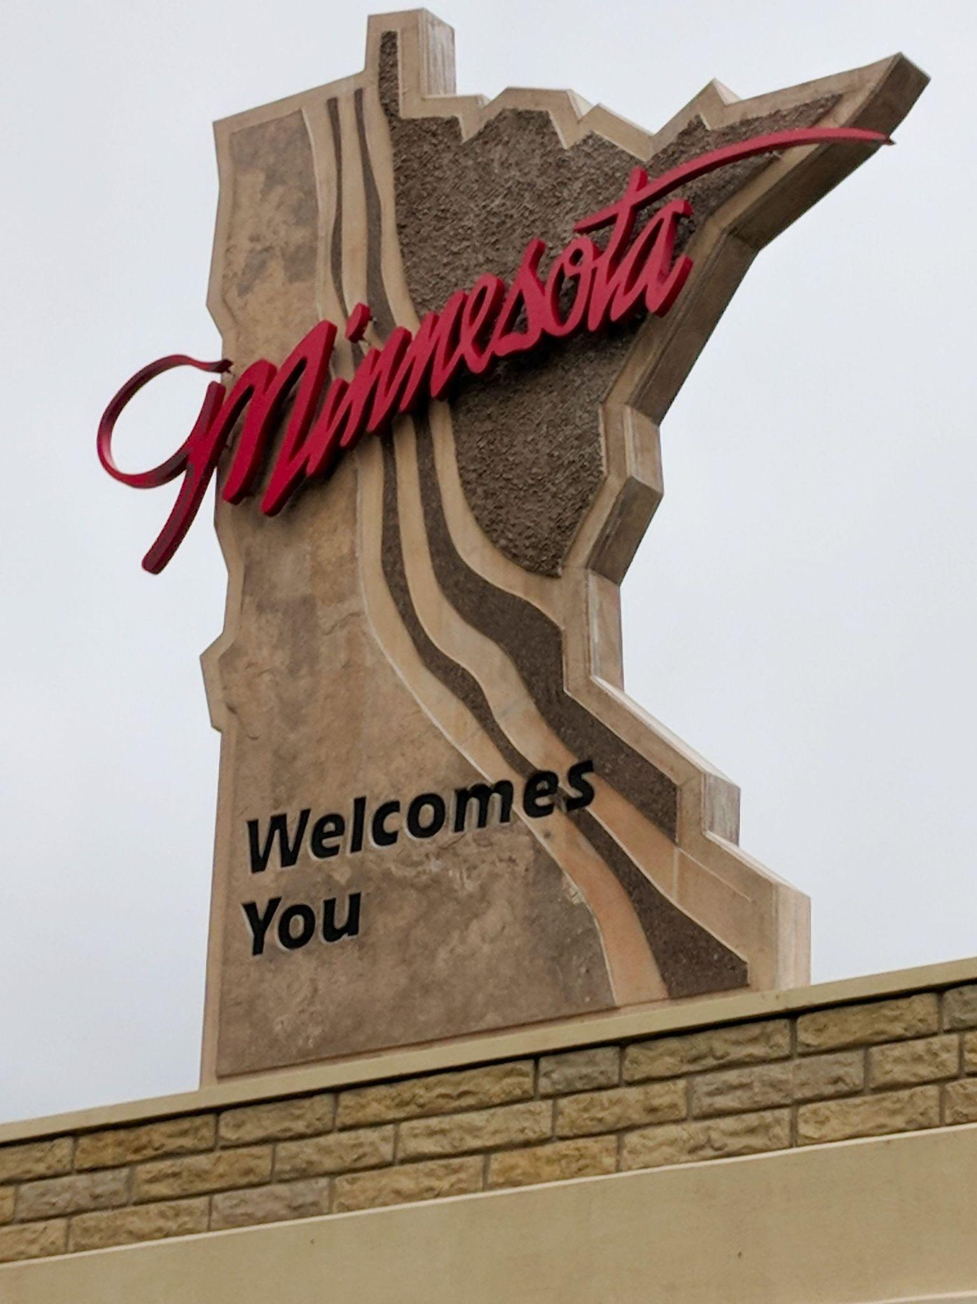

SUPPORT SERVICES CONFERENCE
Professional Development for ABE Support Staff

Thursday, November 12
&
Friday, November 13, 2026 2026
Virtual via ZOOM!

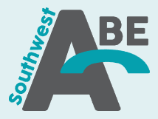
Sponsored by:

CONFERENCE AGENDA
Thursday, November 12th
Click on the JOIN LINK to access the Zoom link.

NOTE: These sessions are intended for anyone who is NOT CASAS or TABE certified or NEW to ABE. You are welcome to attend this portion of the conference even if you do not have program support duties.

TIME | SESSION
9:00 AM - 12:00 PM | CASAS Implementation  Marty Olsen, State Assessment Trainer for CASAS & TABE, SW ABE MN ABE Assessment Supplemental Services Grant  Jeff Galbavy, State Assessment Trainer for CASAS, ABE Facilitator with Metro East  REGISTRATION LINK  This session covers selecting and using the appropriate CASAS test, interpreting test scores, and measuring student progress. Discussion will focus on CASAS appraisals, pre‐ and post‐tests, and introduce online instructional resources. Information about CASAS GOALS 2 & STEPS will be included. Participants who complete this session will be authorized to order and administer CASAS multiple-choice assessments.
12:00 - 1:00 PM | BREAK
1:00 - 4:00 PM | TABE Implementation  Linda Keller, State Assessment Trainer for CASAS & TABE, Metro North Adult Basic Education, Accountability Coordinator  Dave Haugen, State Assessment TABE trainer and currently teaches new student orientations with Minneapolis Adult Education.  REGISTRATION LINK  This session covers selecting and administering TABE 13/14 tests, interpreting test scores, and measuring student progress. Discussion will focus on best practices for using the TABE Locator, and pre‐ and post‐tests. The latest updates on TABE 13/14 will be shared. Print and online instructional resources will be discussed.
.
Please note: Presenter materials will not be available until after the session has concluded. Conference sessions for Friday, November 13 will be recorded and found on the MN Adult Education Professional Development YouTube page.

CONFERENCE AGENDA
Friday, November 13th
Click on the JOIN LINK to access the Zoom link.

NOTE: These sessions are intended for anyone. You are welcome to attend the conference even if you do not have program support duties.

TIME | OPENING SESSION
9:00 - 9:45 AM | Brad Hasskamp, Jodi Versaw, MN Department of Education  Jenny Schlukebier, SiD Coordinator  Rachel Stiglitz, SPARC Chair  Marty Olsen, SW ABE MN ABE Assessment Supplemental Services Grant  REGISTRATION LINK  Welcome and thank you for participating! Our state leadership will provide updates of the state of Adult Basic Education in Minnesota.
CONCURRENT SESSION 1
10:00 - 10:45 AM | Remote Assessment Hub  Marty Olsen, Lead State Assessment Trainer for CASAS & TABE  Linda Keller, State Assessment Trainer for CASAS & TABE, Metro North Adult Basic Education, Accountability Coordinator  JOIN LINK If needed MEETING ID:  Minnesota ABE has implemented a new Minnesota Remote Assessment Hub for students who are unable to come into the physical building to test. This is a great option for students who are attending your classes virtually. Your state CASAS trainers will explain how the Hub works, which students are eligible to access it, the responsibilities of the program, and the expectations of the students.
10:00 - 10:45 AM | United Way 211: Connecting students to services they need  Danielle Davis, Community Resource Specialist  JOIN LINK If needed MEETING ID:  United Way 211 is a dedicated three-digit helpline that individuals and families in Minnesota can call to access free and confidential information about health and human services. This session will inform staff on how to access the 211 website for searching resources as well as what methods of receiving resources are available through 211 and ways to encourage clients to utilize 211 to their benefit.
10:00 - 10:45 AM | Why GED Learners Persist, or Not  What GED® Data Reveals About Motivation, Momentum, and Success  Kris Mehan, Insights Specialist, GED Testing Service  JOIN LINK If needed MEETING ID:  Each year, more than 750,000 learners begin their GED® journey, yet many do not persist through testing and credential completion. Understanding where learners struggle – and what drives success – is key to improving outcomes. In this data-driven session, presenters will share national trends in GED® learner motivation, persistence, and completion using large-scale, longitudinal data.
CONCURRENT SESSION 2
11:00 - 11:45 AM | CASAS Recertification  Marty Olsen, State Assessment Trainer for CASAS & TABE, SW ABE MN ABE Assessment Supplemental Services Grant  JOIN LINK If needed MEETING ID:  Minnesota ABE assessment policy states that CASAS test administrators need to be recertified every 5 years. This session will satisfy that requirement and provide updated information on the CASAS test series including STEPS for ELL, GOALS Reading 2 and Math 2. We will review standardized testing, look at tools that CASAS provides to support instruction, and view the reports and resources available to support your testing process. This session is for experienced test administrators.
11:00 - 11:45 AM | Empathy Meets Efficiency: Dialectical Thinking in ABE Customer Service  Jessica Ess, Distance Learning Advisor, Hubbs Center (St. Paul ABE)  JOIN LINK If needed MEETING ID:  ABE student service professionals often feel the tension between empathy and efficiency. But are the two mutually exclusive? This session introduces dialectical thinking as a practical tool to help both students and staff move from an either/or mindset to a both/and mindset when considering common barriers in adult education. Through ABE scenarios, participants will explore how to help students reduce barriers, improve customer service, and potentially increase student retention.
11:00 - 11:45 AM | Updates from GED Testing Service  Mellissa Hultstrand, MN GED State Relationship Manager  JOIN LINK If needed MEETING ID:  This session is designed specifically for GED® Program Managers and Coordinators. First, we will review 2025-present MN GED testing data and then we'll review the many updates we have made in the last year to the GED App, GED Manager, the GED® website and student accounts, ensuring you are informed about the latest enhancements.
12:00 - 1:00 PM | BREAK
CONCURRENT SESSION 3
1:00 - 1:45 PM | TABE Recertification  Linda Keller, State Assessment Trainer for CASAS & TABE, Metro North Adult Basic Education, Accountability Coordinator  JOIN LINK If needed MEETING ID:  Minnesota ABE assessment policy states that TABE test administrators need to be recertified every 5 years. This session will satisfy that requirement and provide updated information on the TABE test series including the new 13/14 series. We will review standardized testing practices, look at tools that TABE provides to support instruction, and view the reports and resources available to support your testing process. This session is for experienced test administrators who have already attended TABE Implementation training in the last 5 years.
SiD Scavenger Hunt
Jenny Schlukebier, SiD Support
Mary Zimmerli, SiD Support

JOIN LINK If needed MEETING ID:
In this scavenger hunt-style session, you can unleash your SiD knowledge and sharpen your analytical thinking skills. We will present some data request scenarios, then set you loose to find the answers in your own program data. We’ll also review how you might have come up with the answers. Join us for this fun interactive session!
Support Staff Training Needs in Corrections
Sarah Wilder, Corrections Teaching Assistant, MN DOC, Faribault
Rachel Stiglitz, Education Coordinator, Ramsey County Correctional Facility
JOIN LINK If needed MEETING ID:

Do you work in corrections? Is one of your roles (or all of them) testing, intake and onboarding, teaching assistant/tutor, volunteer coordinator, data specialist and/or office manager? Sarah, with MCF-Faribault (the largest DOC facility), and Rachel, with the Ramsey County Correctional Facility (a local jail), will share what their programs look like, and facilitate a discussion around what the challenges are working in these institutions.
What topics would you like to address? This session is focused on identifying the specific challenges staff face working with students in corrections with the intention of developing more professional development focused on correctional settings.
CONCURRENT SESSION 4
2:00 - 2:45 PM | Distance Learning Data in SiD: What You Should Know  Susan Wetenkamp-Brandt, Senior Manager - EdTech & Digital Learning, Literacy Minnesota  Jenny Schlukebier, SiD Support  JOIN LINK If needed MEETING ID:  Refresh your knowledge about all things DL data including understanding the reports from DL platforms and how to accurately create classes and take attendance for DL classes in SID. Bring your questions, & we will have time to address them.
2:00 - 2:45 PM | Digital Skill Building for Remote Testing Success  Elizabeth Bennett, Statewide Digital Learning Specialist, Literacy Minnesota  JOIN LINK If needed MEETING ID:  Remote testing, especially the statewide Remote Assessment Hub, can be an accessible, convenient, and affordable way for learners to complete required tests and for programs to improve their post-testing rates - but only if learners have the digital skills required to test remotely! In this session, you’ll learn practical tips and access free resources to support learners with navigating email, Zoom, Calendly, and common device issues.
2:00 - 2:45 PM | CASAS TOPSpro - Navigating Teacher Portal  Adrian Boggess, Tech Support and Trainer  Astrid Robitaille, National Program and Online Training Specialist  Minnesota State Navigator  JOIN LINK If needed MEETING ID:  This beginner-friendly session will provide an introduction to Teacher Portal user access, including roles, permissions, and how users gain access to the system. Participants will also take a guided tour of the Teacher Portal interface and learn about key features available to instructors. By the end of the session, attendees will have a basic understanding of how to navigate Teacher Portal, access student information, manage classes, and utilize common instructional tools to support their teaching and reporting needs.

Participant materials folders can be found HERE.

Please note: Presenter materials will not be available until after the sessions have concluded. Conference sessions for Friday, November 14 will be recorded and found on the MN Adult Education Professional Development YouTube page.

Thank you to our sponsors!!!
Southwest ABE and MN Assessment Training Grant
(visit the assessment website to learn more about CASAS & TABE testing and SPARC!)

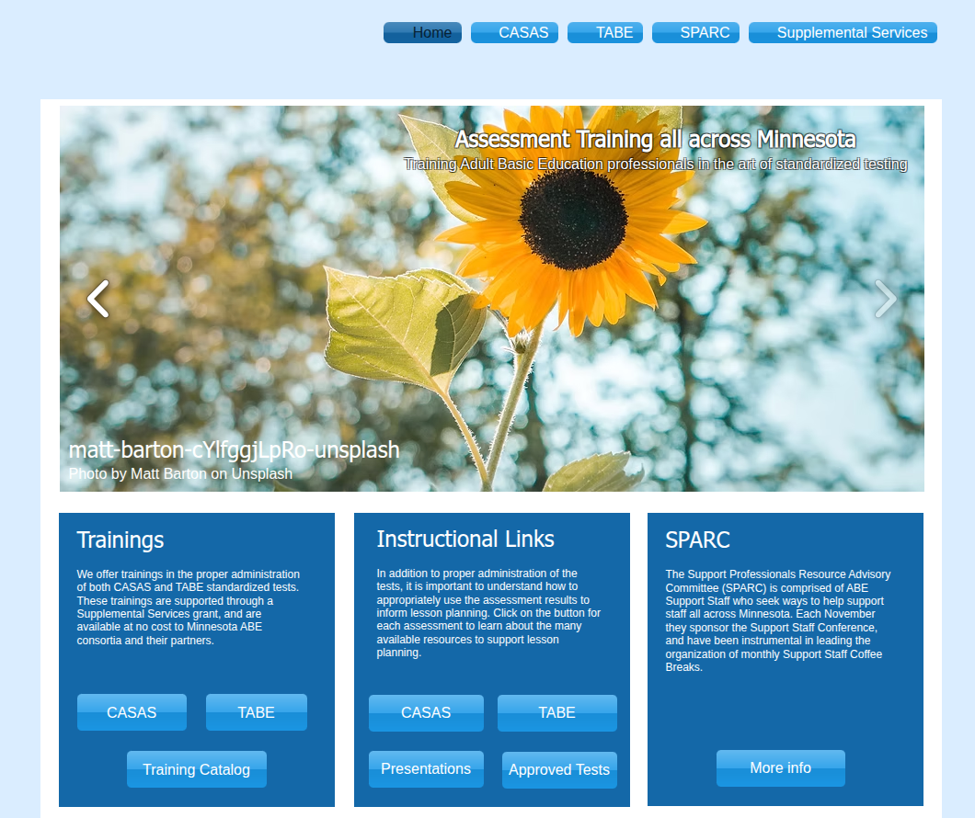

Minnesota Adult Education
Visit the MN ABE website to learn about Adult Education in our state!
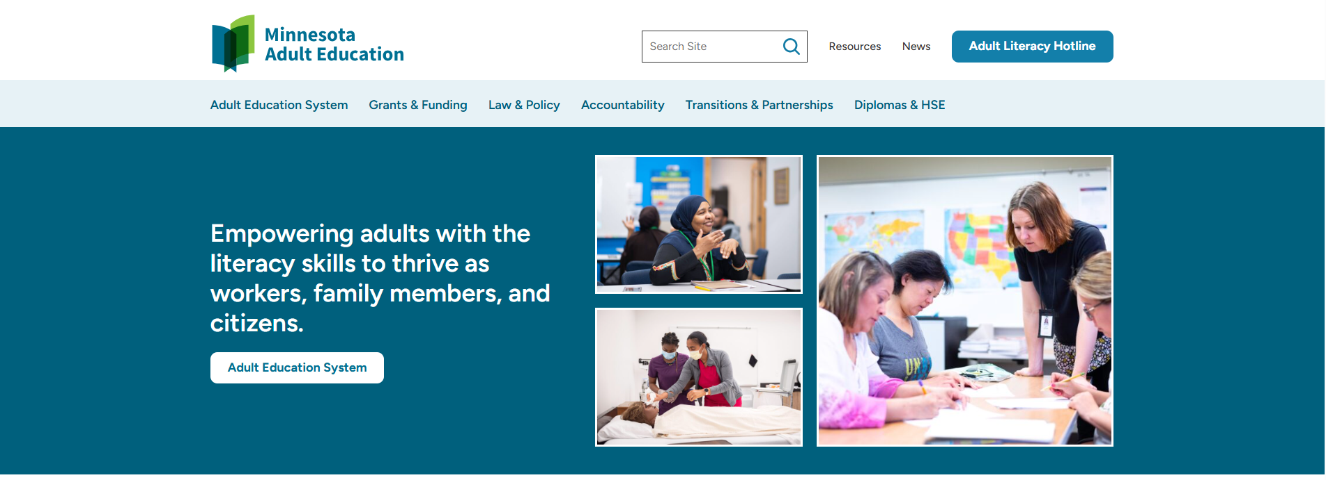

We appreciate your taking the time to participate!

The conference is organized by the members of SPARC (Support Professional Advisory Resource Committee). Thank you to all who planned and supported the conference, including:

Rachel Stiglitz, Metro East ABE
Linda Jacobs-Buse, South Suburban ABE
Cindy Morgan, Minneapolis ABE
Jess Ess, Saint Paul ABE
Jeff Galbavy, Metro East ABE
Astrid Liden, MN Department of Education
Melinda Doll, Moorehead ABE
Jenny Schlukebier, SiD support
Marty Olsen, SW ABE
Alec Lunneborg, Metro South ABE
Jose Pinto, Minneapolis ABE
Linda Keller, Metro North ABE
Michael Redman, Metro North ABE
Laura Malott, CLBW ABE

A very special THANK YOU goes to the following:

ATLAS (ABE Teaching & Learning Advancement System) for lending assistance and technical support.

Cover photo by Stephen Fischer, Pexel Free Stock Photos (https://www.pexels.com/photo/a-red-text-signage-9738583/)

We appreciate the support and resources from our Minnesota ABE Supplemental Service Providers.

Thank you to our presenters for sharing their time and expertise!

Jeff Galbavy has been in community education for 7 years, adult education as an ABE Facilitator with Metro East for 4 and a half years, working with CASAS eTesting remotely for the past 4 years. jgalbavy@isd622.org

Brad Hasskamp is the State Adult Education (ABE) Director at the Minnesota Department of Education. With his work on the state ABE team, his primary responsibilities include state high school equivalency test administration, standard adult high school diploma administration, and federal and state policy implementation. brad.hasskamp@state.mn.us

Dave Haugen, State TABE Assessment trainer, has worked in Adult Ed since 2013 in various roles including as a Testing Coordinator (Minneapolis Adult Education), as an ESL Instructor (Metro North Adult Ed), and currently teaches new student orientations with Minneapolis Adult Education. He has a Masters in Education (2013) and Public Administration (2010), and currently works at Pearson VUE. dave.w.haugen@gmail.com

Mellissa Hultstrand is a GED State Relationship Manager. She is responsible for coordinating all GED® matters for ABE within MN. Mellissa has been with GEDTS since 2012, and prior to her SRM role, she was a high school teacher and senior member of the GEDTS Operations & Training Team. Mellissa.Hultstrand@GED.com

Linda Keller is currently a state certified trainer for CASAS and TABE in MN ABE. Linda has been in support staff roles in adult Ed, since joining Metro North in the mid-1990s, and has been the Metro North Accountability Coordinator since 2005. Lindam.keller@ahschools.us

Marty Olsen is a nationally certified CASAS trainer and a state-certified TABE assessment trainer. She manages the Assessment Training supplemental services grant for Southwest ABE. martha.olsen@gmail.com

Jenny Schlukebier works for Minnesota ABE in development and support of the SiD data system. Jenny comes from a background of working on accountability in ABE at St. Paul Public Schools ABE (Hubbs Center) and MLC. jenny.sidmn@gmail.com

Rachel Stiglitz is the current SPARC Chair, facilitator for the ABE Foundations online course, and the Education Coordinator for the Ramsey County Correctional Facility (member of the Metro East Consortium). rachel.stiglitz@gmail.com, rachel.stiglitz1@ramseycountymn.gov

Jodi Versaw is the Adult Basic Education Program Quality Specialist at the Minnesota Department of Education. With her work on the state ABE team, her primary responsibilities include the five-year narrative, program improvement, and program support. jodi.versaw@state.mn.us

Mary Zimmerli works for Minnesota ABE in development and support of the SiD data system. maryz.sidmn@gmail.com

